

Options for GenAI use in your course – Fall 2024

College of Arts and Science
This resource was developed following meetings of faculty from the College of Arts and Science in March-April 2024 and it is intended to assist in communicating expectations for GenAI use for teaching.
Instructors may copy and paste text and graphics from this resource to use in their syllabi and/or assessment related instruction.

Consider GenAI-use options that apply to your assessment, choose from examples:
- No GenAI use
May be appropriate when a learning outcome requires students to produce entirely unassisted work.

- Some GenAI use
3 subcategories appear here, each with non-exhaustive example lists. Depending on the context for the assessment, you may find an example could better fit in another category.
  - Idea generation, structuring
    - Suggest a research question, key points, topic areas
    - Create an outline for an essay, paper or report
    - Outline steps to solve certain kinds of problems
    - Generate examples of something that was explained in class
    - Sort ideas according to criteria
    - Summarize key points from text inputted as a prompt
    - Recommend approaches for conducting research​
    - Identify strategies that could work for an example problem or context​
    - Generate counter-arguments to key points​
  - Editing assistance
    - Proofread a draft for certain kinds of errors or issues
    - Rewrite a student paragraph in a different tone
    - Find ways to restate or vary word choice
    - Get feedback and advice on a draft
    - Rewrite a student draft for improved grammar, verb tense
    - Assemble drafted content into a more cohesive whole
    - Improve a thesis statement or research question
    - Rewrite a draft to change word count
    - Translate from one language into another
  - Task completion
    - Classify content
    - Transform large data set
    - Create a glossary of terms
    - Generate a case study, piece of art, concept map, thematic representation
    - Design an experiment or process
    - Simulate a process or experiment
    - Curate content to represent a theme or an argument
    - Simulate an interview with a specific person, character or persona
    - Analyze data for patterns, properties, interactions
    - Generate code for a standard or novel problem
    - Change a text-based story into a visual, or vice versa
    - Redesign something to new specs

- Full GenAI use
May be appropriate when it is part of a learning outcome that students be able to leverage and use the technology and demonstrate proficient and ethical use as would be expected in applied contexts.
Look at more resources
- Sample syllabus statements with rationale available here
- Sample acknowledgement practices, including non-use and permitted use available here
- Citation style guides here and Library GenAI Guide here
- USask’s AI Task Force guidelines for educators, students
- About Co-Pilot, approved GenAI tool at USask
Use a graphic representation to show continuum of use
Instructors may copy and paste this graphic and highlight a level of use that you regard as acceptable. Simplified visuals can help students recognize where instructor expectations exist on a kind of continua of use. Adoption of a standard graphic across courses can reduce student confusion with respect to the mix of expectations across courses and signal them to pay attention to specific permitted uses where applicable. A PDF version (provided) allows for the checking of boxes.
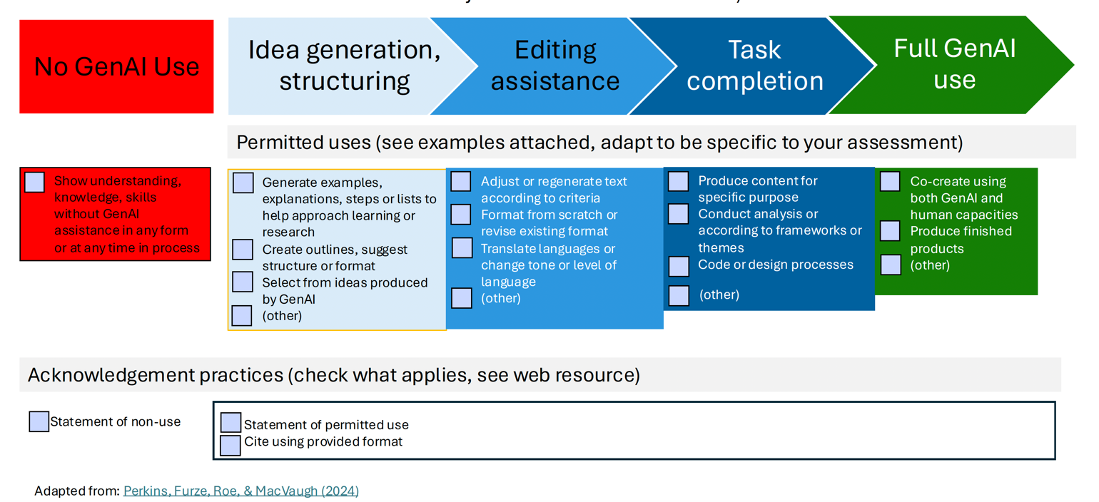
Use a table that indicates levels of use
Instructors may copy and paste the table on the following page, adapted from Perkins et al (2024). Consider the language provided for stating expectations that are shown on a scale.
1.  NO AI | The assessment is completed entirely without AI assistance. This level ensure that students rely solely on their knowledge, understanding, and skills  AI must not be used at any point during the assessment
2.  AI-ASSISTED IDEA GENERATION AND STRUCTURING | AI can be used in the assessment for brainstorming, creating structures, and generating ideas for improving work.  No AI content is allowed in the final submission
3.  AI-ASSISTED EDITING | AI can be used to make improvements to the clarity or quality of student created work to improve the final output, but no new content can be created using AI  AI can be used, but your original work with no AI content must be provided in an appendix.
4.  AI TASK COMPLETION, HUMAN EVALUATION | AI used to complete certain elements of the task, with students providing discussion or commentary on the AI-generated content. This level requires critical engagement with AI generated content and evaluating its output.  You will use AI to complete specific tasks in your assessment. Any AI created content must be cited.
5.  FULL AI | AI should be used as a ‘co-pilot’ in order to meet the requirements of the assessment, allowing for a collaborative approach with AI and enhancing creativity.  You may use AI throughout your assessment to support your own work and do not have to specific which content is AI generated.
Source: Perkins, Furze, Roe, & MacVaugh (2024) Link
College of Arts and Science Generative AI Working Groups Summary (April 2024)
Statements of Practice

- We believe context matters for the use of GenAI in teaching and learning practices, and our answers and policies reflect that knowledge.
- With learning at the forefront of our teaching practice, how students learn is important to us as a teaching community. The process by which we learn is as important as the product created.
- Instructors value tools that will support learning; not replace learning.
- We aim to prioritize the safety of our students, ourselves, and our learning communities with respect to the use of Generative AI.
- We value and uplift practices that reflect academic integrity and the reputation of our courses, instructors, College and the University. An awareness and understanding of the opportunities and challenges regarding GenAI can lead to responsible action.
- Generative AI requires a shift in assessment practices, being ever mindful of students including English language learners and students with AES accommodations, who can benefit from the support of technology that incorporates AI.

- The technology is changing quickly and we expect the need to continually adapt as it responds, improves and evolves.
- We owe it to our students and ourselves to have clarity about our beliefs and expectations when it comes to GenAI.
- It is important that instructors are able to interrogate their thinking and decisions regarding the use of and the degree to which GenAI is permitted within each assessment.
- It is important that instructors are then able to articulate their intentions and communicate them to students.
- Practices could include sharing the prompt questions and reflective answers with students so that everyone is aware of the rationale regarding the use of and the degree to which GenAI is permitted within the assessment.

Key questions to ask as instructors
- What do you want our students to learn and to practice?
- What is the purpose/intention/goal of the task or assessment?
- Would GenAI tools affect the learning of the skills we want students to develop?
- What stage of learning are our students at? Are there different expectations and skill sets that are then required based on the students’ current stage?
- Is this an assessment in which touchpoints could be put in place to sequence the learning?
- Would the use of GenAI positively or negatively affect the content of the outcome or demonstration of learning?
- Would the use of GenAI positively or negatively affect the process of the learning?
- Is there evidence that students would still be demonstrating independence in the learning process if they were to use GenAI tools?
- Have you provided a rationale to the students regarding your decision to allow or not allow Generative AI?

Provisional Principles: https://leadership.usask.ca/documents/initiatives/provisional-artificial-intelligence-principles.pdf
Provisional Educator Guidelines
1. Ethical and Responsible Use
- Promote Openness and Transparency: You should demonstrate transparent use of AI by acknowledging its uses and fostering a culture of openness where students are encouraged to ask questions and disclose AI use (see more information on citing).
- Protect Intellectual Property: You should not input students’ intellectual property into AI tools.
- Attend to Equity and Diversity: You should encourage searching for diverse knowledges and caution that AI outputs are subject to inequities.
2. Literacy
- Familiarize Yourself: You should familiarize yourself with the fundamentals of AI, including its benefits, limitations, and potential applications, as well as its social, cultural, and ethical implications.
- Task-Specific Use: You should promote the use of specific AI tools for specific tasks in teaching and learning and integrate authentic uses of AI given your discipline.
- Keep Current: You should be aware of AI usage and its impact in relevant industry and community contexts (see more on prompting)
3. Change and Innovation in Instruction and Assessment
- Find Balance: You should guide learners in using AI tools and developing their own creative and critical thinking skills. Focus on uniquely human abilities in learning outcomes, instruction, and assessment.
- Set Expectations: You should discuss expectations with learners about appropriate AI use and its impact on learning, including accountability for any use of AI output, and disclosing AI use.
- Responsibility: You are responsible for assessing student work, feedback quality, and establishing student grades, although you can be supported by AI.
- Consistency: You should collaborate within your program to apply concise and consistent expectations for use of AI.
4. Managing Tool Use
- Tool Approval and Recommendation: You should prioritize using AI tools approved by USaskto protect equity, safety, and security. When functionality needs for your course are better met by unapproved tools, you should recommend new tools to be reviewed.
- Weigh Implications: You should weigh implications for student learning needs (including accommodation), course outcomes, and assessment security if you are considering banning the use of AI for an assessment. Seek guidance about best practices before making decision about how to secure your assessments.

Provisional Student Guidelines
Artificial Intelligence (AI) is rapidly changing how we do many things, including how we teach and learn. It is critically important to dialogue with others, including your instructor, in all parts of your learning process, including when you are considering using or using AI.
Learn To
- Recognize when and how you are using AI, and how this impacts your learning
- Prioritize your creativity, critical thinking, and problem-solving skills, using AI to complement your learning
- Explore the current and future use of I in your field of study and potential workplaces. Research and choose appropriate tools to leverage
- Use a CLEAR framework to interact with AI , refining what you do or ask to obtain relevant and desired results. Modify what you do or ask using AI to increase accuracy, reduce bias, and improve quality of AI outputs, and to evaluate the quality of what you receive from AI .
  - Action item: Verify the information provided by AI with credible sources and use it as a supplement, rather than a replacement, for traditional search methods.
Use Responsibly
- Use AI to support your learning, not to replace or misrepresent your learning.
  - Action Icon: Follow the rules laid out by instructors about use of AI to act with integrity and avoid academic misconduct .
  - Action Icon: Seek clarification about expectations early and often.
  - Action item: prioritize dialogue with your instructor and peers over dialogue with conversational AI.
- Identify when and how you are using AI and use citation , disclosure, and acknowledgement processes appropriately, given the circumstances.
  - Action Icon: Seek clarification about when its use is appropriate because instructions may not be explicit enough, and instructors may not consider this until they are asked.
  - Action Icon: Expect to be asked by instructors about your process for producing content, including your process for working with or prompting AI.
- Act respectfully after considering the ethics surrounding a range of AI uses in your personal, academic, and professional life.
Protect Yourself
- Choose tools that are USask approved for your privacy and security rather than other GenAI tools.
  - Action Icon: Safeguard your privacy and security. Ensure you use a unique username and password and avoid reusing your NSID and NSID password.
- Because many AI tools retain what you put into them, do not use other people’s work without authorization.
  - Action icon: Your work should entered into AI detection or other third-party tools without your permission.
- Advocate for AI policies across contexts that protect privacy, security, transparency and environmental sustainability.

